The Sermon on the Mount, Part 1 (8 of 10)
Small Group Discussion Questions
Join our congregation for worship in-person or online at 10:30 am each Sunday via our Grantham Church YouTube Channel. If you ever miss a message, the sermons are always posted to the recent sermons page at our website and at the Grantham Church Podcast the following day, along with the sermon slides and small group discussion questions under Worship Resources. Thank you for staying connected with us!
Sunday, October 26th, 2025
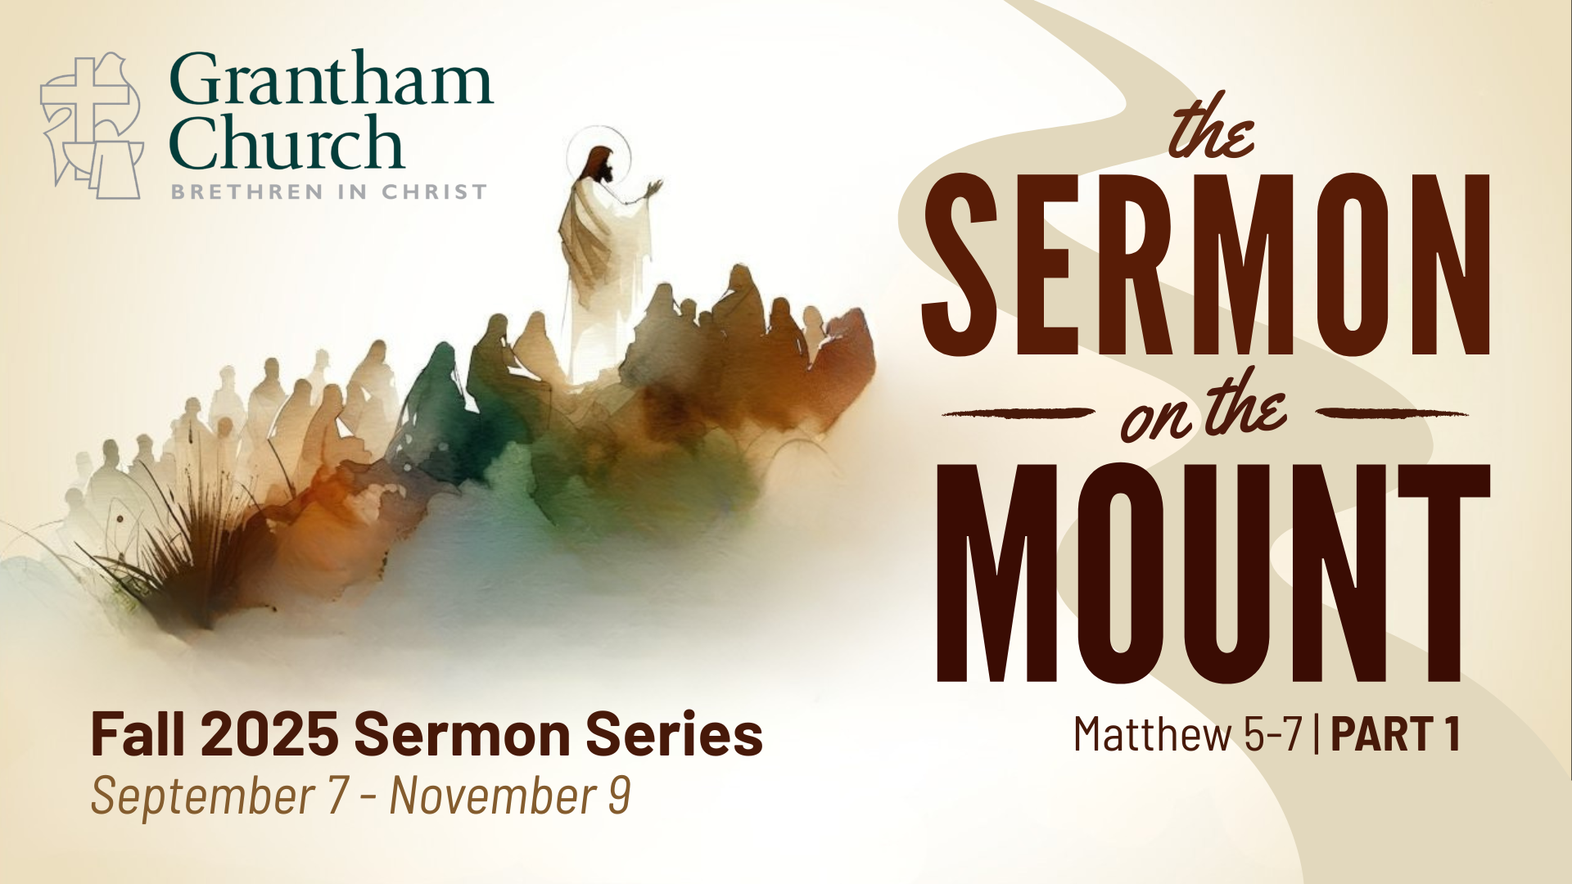

Sermon Series Summary
Matthew 5-7 is known as the Sermon on the Mount. Jesus went up a mountain and a large crowd gathered to hear him preach a powerful message—proclaiming the gospel of the Kingdom and casting a vision of what it looks like to live in right relationship with God, our neighbors, and our enemies. These three chapters contain the core of Jesus’ teachings and his most well-known sayings, including some of the most rigorous ethical demands in the Bible. Join us for Part 1 of this series (Sept 7-Nov 9), as we explore the message and implications of Jesus’ invitation to enter the narrow gate and follow him.

Sermon Title: Straightforward Speech
Scripture Reading: Matthew 5:33-37
Sermon Focus: We live in a culture of manipulation, spinning the truth, and keeping our options open. But Jesus calls out our tendency to deceive and hold back and invites us into a life of integrity and honesty. In the eighth message of our series, Pastor Melissa guides us through Jesus’ teaching on oaths and encourages us to be a community who follows through with our commitments.
Thank you for going deeper in conversation with your small group. Use the following questions to help guide your small group discussion:

- Read Matthew 5:33-37. What stands out to you from the passage? Skim the verses before and after this section. How does this teaching relate to that context?

- Pastor Melissa talked about how the common practice at the time of Jesus was to invoke the reputation of God as a way of manipulating others to get what you want. How do we do this today?

- In swearing on other things, the ancient Israelites were trying to disconnect those places or things from the presence and rule of God. Is there a way or area of life where you notice you do that? What does it mean to be a person of integrity? How can we grow as a church in being integrated in our beliefs, words, and actions?

- The heart of Jesus’ teaching is about being honest and following through with our commitments. Why do people today struggle with commitment?

- What kind of community is formed when we stay true to our word? What will it take for your small group to be a community of trust and loyalty? What about Grantham Church more broadly?

- LIFE ON MISSION QUESTION: Our society is becoming more and more shaped by manipulation, untruth, and being non-committal. Could you imagine talking about this passage or concept with a non-Christian friend? What might that look like? How could you engage with them about Jesus’ teaching on a personal level?

- Pray together in response to what you’ve discussed and for the needs in your group. Ask God to make you a community together that is honest, trustworthy, and committed. Pray that others would see and benefit from your beautiful, cruciformed community.

